San Jose State University

Department of Computer Science

Professor: Ahmad Yazdankhah

**Project: Technical Specification**

Team Optiplex

Fion Leong

Mitchell Sarmento

Naghmeh Anvari

Brendon Yim

Fall 2016

**Table of Contents**

**Table of Figures** **2**

**1. Introduction**  **3**

* + 1.1 Objective 3
  + 1.2 References 3
  + 1.3 Acronyms, and abbreviations 3

**2. System Overview**  **4**

* + 2.1 Problem Statement 4
  + 2.2 Scope of the system 4
  + Technological Requirements 4

**3. System Architecture**  **5**

**4. Detailed Design** **6**

* + 4.1 Use-case UML Diagrams 6
  + 4.2 Class UML Diagrams 7
  + 4.3 Sequence UML Diagrams 8
  + 4.4 State UML Diagrams 8
  + 4.5 Database Architecture 9
  + 4.6 User Interface 10

**Table of Figures**

Figure 3.0 : High Level Block Diagram 5

Figure 4.1 : Use Case UML Diagram 6

Figure 4.2 : Class UML Diagram 7

Figure 4.3 : Sequence UML Diagram 8

Figure 4.4 : State UML Diagram 8

Figure 4.5 : Database Architecture 9

Figure 4.6.1 : Navigation Bar Menu 10

Figure 4.6.2 : Login Form 10

Figure 4.6.3 : Sign Up Form 11

Figure 4.6.4 : Contact Form 11

Figure 4.6.5 : User Profile Form 12

Figure 4.6.6 : Successful\_signup Form 12

Figure 4.6.7 : Filter Select Form 13

**1. Introduction**

**1.1. Objective**

This document contains a technical specification of Senior Companion Care (SCC). The document includes a summary of features about SCC: problem statement, the scope of the system, technological requirements, and system architecture. The audiences for this product are caregivers and care seekers. Audiences with basic internet knowledge will be able to use our product without any assistant.

**1.2. References**

[Mention the references of all documents, websites, books, and so forth, you used for

creating this document.]

Lecture Notes - F16-Ahmad Y-CS160-L12.pdf

Bootstrap - <http://getbootstrap.com/>

MySQL - <https://www.mysql.com/>  
Star UML - <http://staruml.io/>

MVC - <https://en.wikipedia.org/wiki/Model%E2%80%93view%E2%80%93controller>

**1.3. Acronyms, and abbreviations**

SCC - Senior Companion Care

UI - User Interface

MVC - Model View Controller

UML - Unified Modeling Language

ER Diagram - Entity Relationship Diagram

**2. System overview**

**2.1. Problem statement**

SCC provides an easy and convenient way for caregivers and care seekers to connect. There are lots of product like SCC on the market but their system is often too cluttered and too difficult to use. SCC solves this problem by providing an easy to use user interface and specifically tailored searches to the care seeker's needs with a few clicks of a button. Care seekers can quickly search for a caregiver that match their needs with SCC’s filtering system.

**2.2. Scope of the system**

The targeted users are any caregivers with or without nursing training or certificate. This system will allow users to sign up regardless of their gender, race, etc. Users that sign up with us will need to be at least 18 years old or older. The other targeted users are the care seekers. However, the system will authenticate user’s identity. If the credentials are not matched, user will not be granted authorization for access.

**2.3. Technological Requirements**

The technologies that we are using for the front end are going to be HTML, CSS, Bootstrap, AngularJS, and JavaScript. For the server-side we will use Java, and SQL for backend.

The technological requirements that the system needs are a web server and an application server which we will be using Apache Tomcat. Also, for data creation and access we will be using MySQL Workbench and MySQL database. We will be using JDBC to connect to the

database. In addition, we will also be using RESTFul Web services.

Our web application is going to be responsive meaning it will respond to the user’s behavior and environment based on screen size, platform, and orientation. Therefore users can view and interact with the web application from any type of browsers and devices.

**3. System Architecture**

Figure 3.0 - High Level Block Diagram

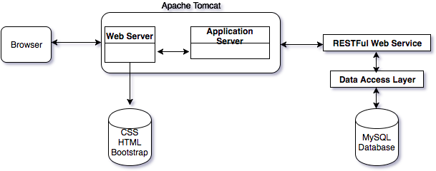

**4. Detailed Design**

**4.1. Use-case UML diagrams (for all use cases)**

Figure 4.1 - Use Case UML Diagram

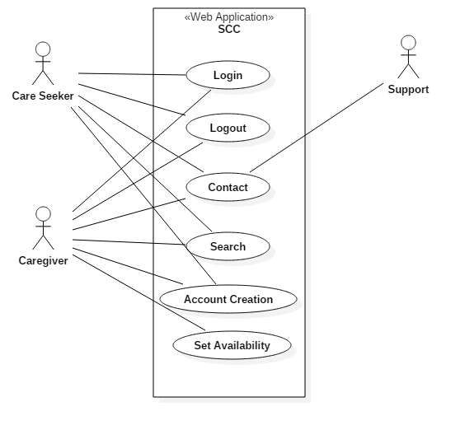

**4.2. Class UML diagrams (for all classes)**

Figure 4.2 - Class UMl Diagram

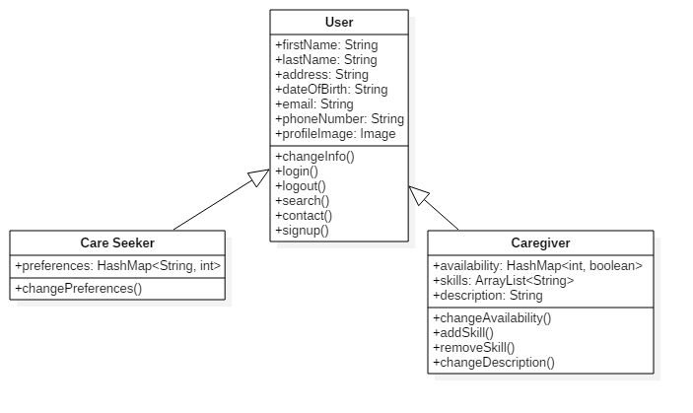

**4.3. Sequence UML diagrams (at least one)**

Figure 4.3 - Sequence UML Diagram

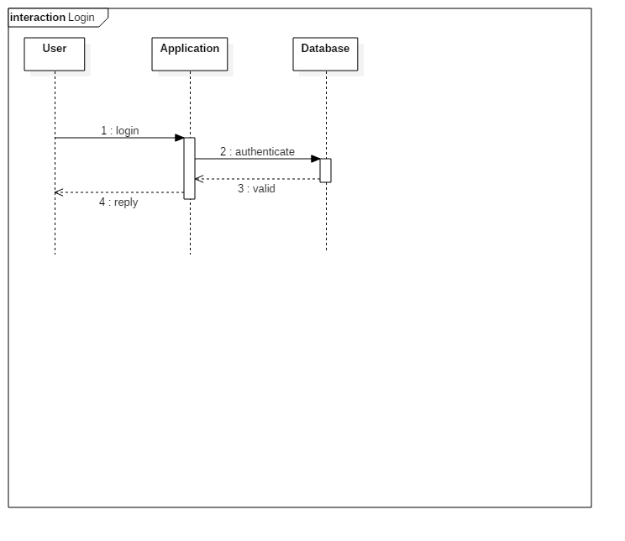

**4.4. State UML diagram (if there is any)**

Figure 4.4 - State UML Diagram

**4.5. Database architecture (ER diagram for all tables)**

Figure 4.5 - Database Architecture

15310473_10211257421970513_507192335_n.png

**4.6. User Interface**

[Include user interfaces snapshots including: side-bar menus, input forms,

messages, output reports and so forth (at least 5)]

***Figure 4.6.1 - Navigation Bar Menu***

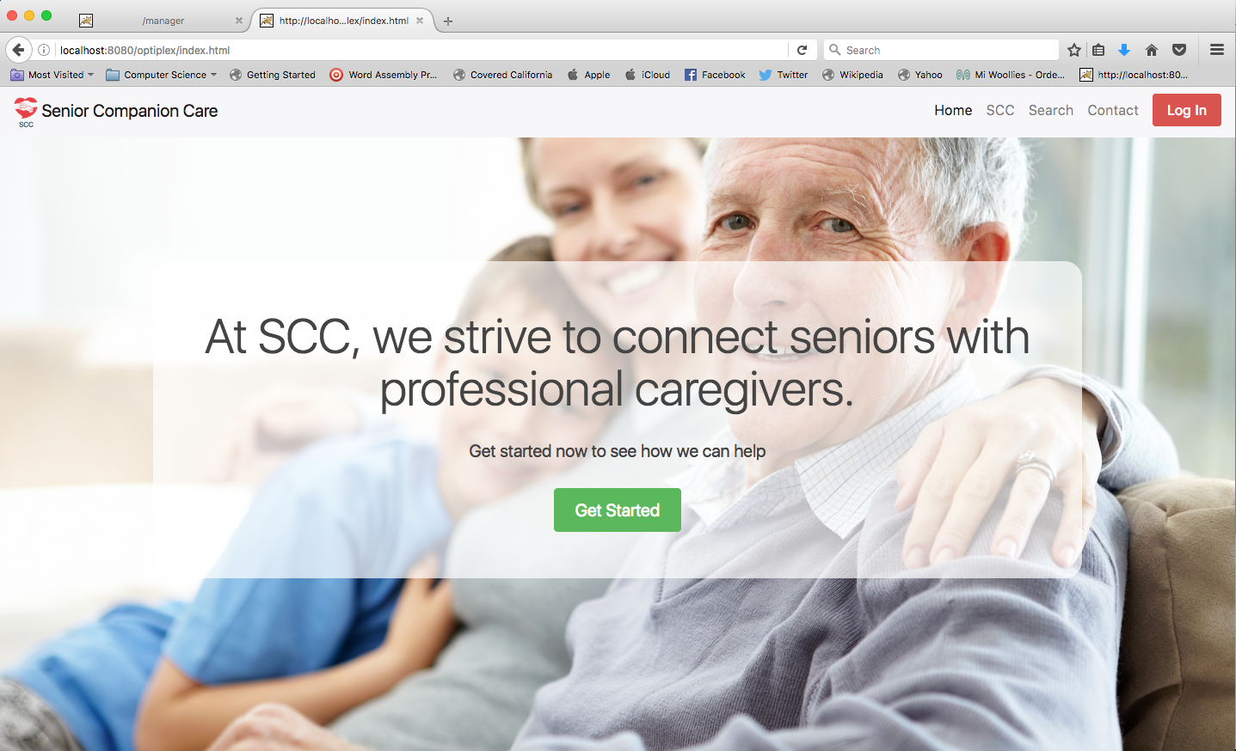

***Figure 4.6.2 - Login Form***

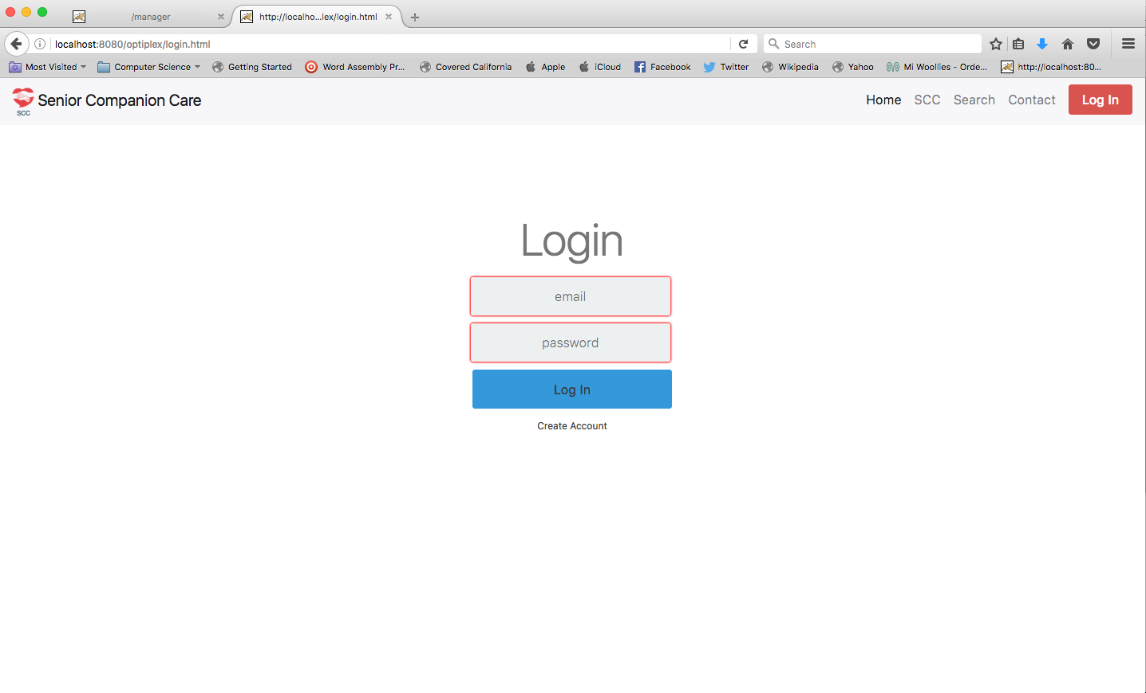

***Figure 4.6.3 - Sign Up Form***

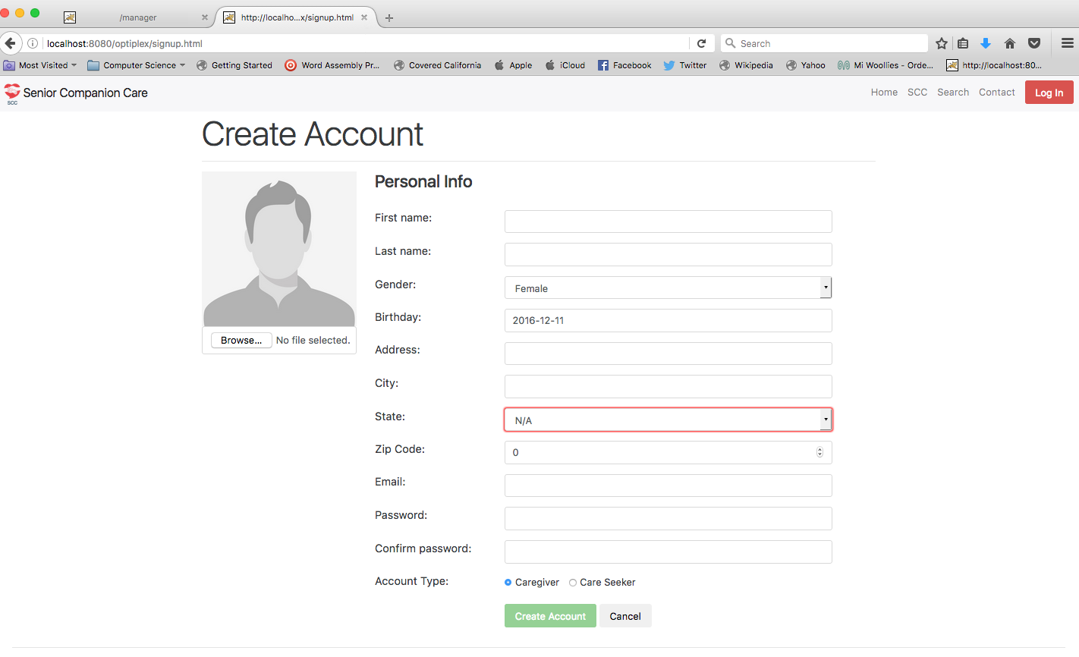

***Figure 4.6.4 - Contact Form***

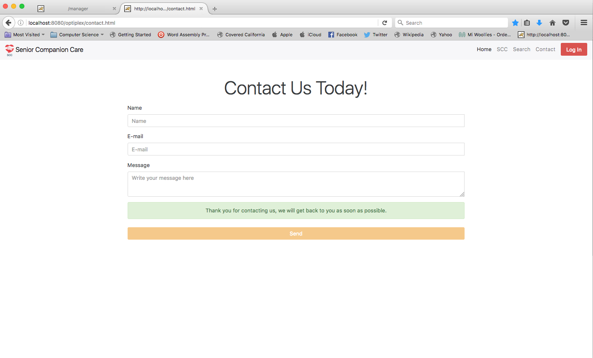

***Figure 4.6.5 - User Profile***

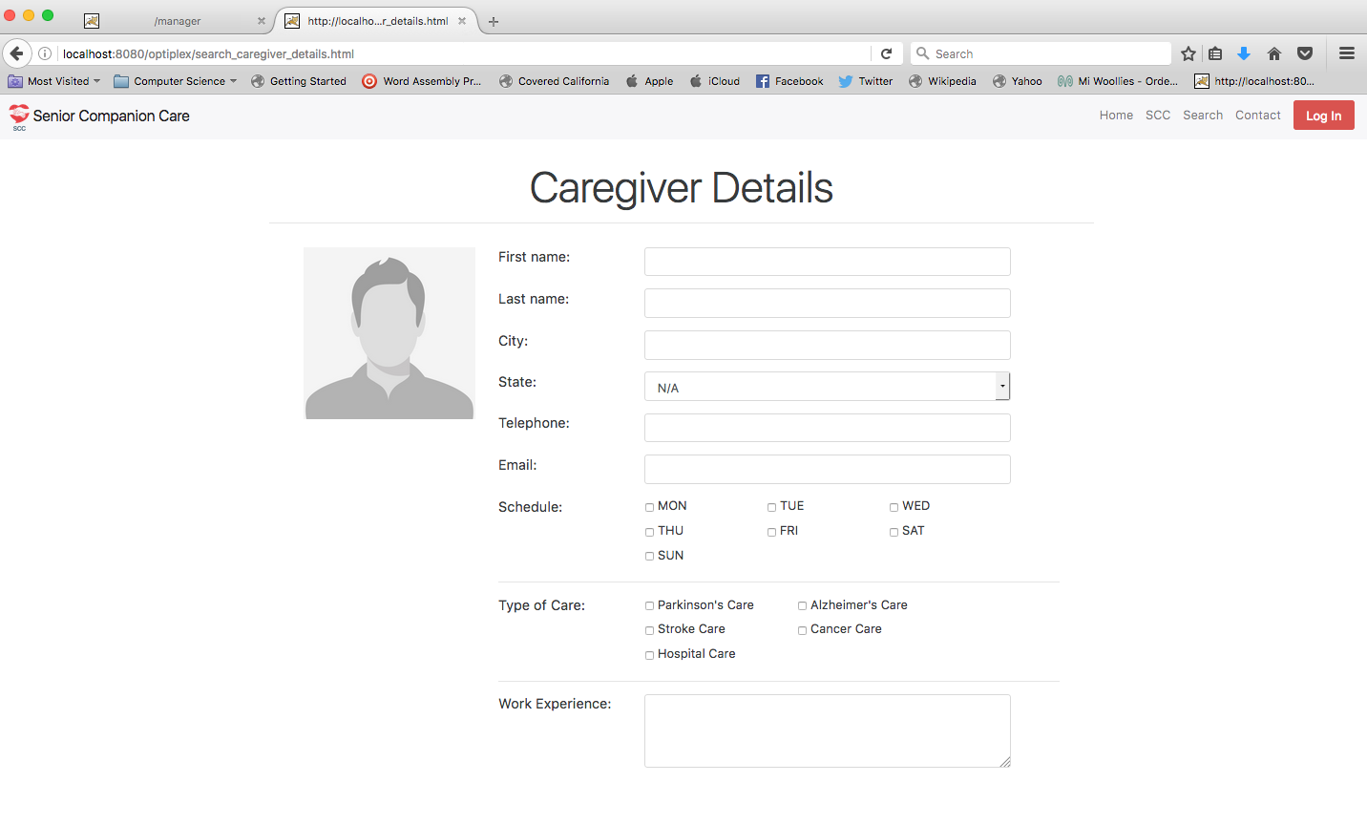

***Figure 4.6.6 - successful\_signup***

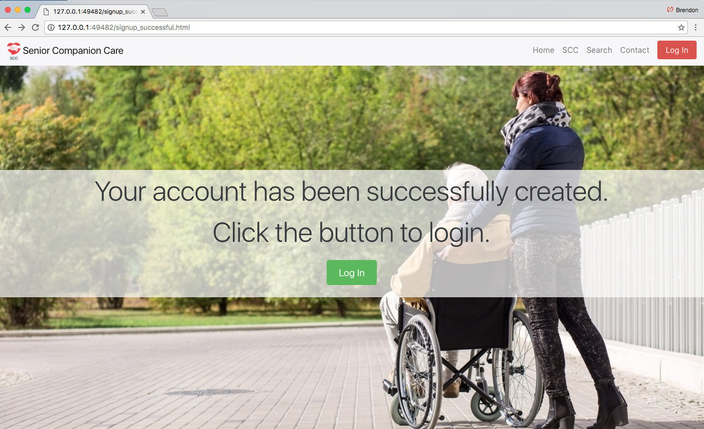

***Figure 4.6.6 - Filter Select Form***

